Infection Prevention and Control Plan for Residential Facilities for Groups

Note: this is only an example, your facility should develop an infection control program specific to your facility population and services, the facility should adopt infection control policies based on your infection control program. The policy must include, without limitation, current infection control guidelines developed by a nationally recognized infection control organization that are appropriate for the scope of service of the facility. Such nationally recognized organizations include, without limitation, the Association for Professionals in Infection Control and Epidemiology, Inc., the Centers for Disease Control and Prevention of the United States Department of Health and Human Services, the World Health Organization or the Society for Healthcare Epidemiology of America, or a successor in interest to any of those organizations.
Infection control recommendations are based on guidelines provided by the Centers for Disease Control (CDC).
Always follow any guidance or instructions from health care providers, local or state health departments, state regulatory agencies, and your organization’s policies and procedures.
Further information to help you develop your infection control program can be found in the following links:
Infection Prevention and Control General Guidance: https://dpbh.nv.gov/Reg/HealthFacilities/dta/Inspections/IPC-General/
Infection Prevention and Control Resources for Residential Facilities for Groups: https://dpbh.nv.gov/Reg/HealthFacilities/HF_-_Non-Medical/Residential_Facilities_for_Groups_(Files)/IPC-AGC/
State of Nevada HCQC Infection Preventionist Email: hcqcipcteam@health.nv.gov

Table of Contents
Introduction ..................................................................................................................... 4
Infection Preventionist..................................................................................................... 5
Infection Control Training ................................................................................................ 6
Standard Precautions....................................................................................................... 8
Hand Hygiene .................................................................................................................. 9
Personal Protective Equipment ..................................................................................... 11
Cleaning and Disinfection.............................................................................................. 14
Respiratory Plan and Etiquette....................................................................................... 18
Sharps............................................................................................................................. 20
When a Resident Has a Communicable Disease............................................................. 22
Emergency Infection Control Plan................................................................................... 23

Introduction

A sound infection control plan is an important part of resident safety and quality care. This plan shall be implemented and updated as necessary to follow guidance from the Centers for Disease Control and Prevention and state public health recommendations.
The plan shall be reviewed and updated at least annually and as needed.
This plan was last reviewed on: DATE

Infection Preventionist

The community will identify a staff person to perform the duties of an “Infection Preventionist.” They do not necessarily have to work under the title of infection preventionist to hold this role.
Our Infection Preventionists
The following individuals have been designated as the Infection Preventionists for this community as primary and secondary, (a) A primary person who is responsible for infection control; and (b) A secondary person who is responsible for infection control when the primary person is absent to ensure that someone is responsible for infection control at all times:
Primary Infection Preventionists Name:
Title:
Phone Number:
Email Address:

Secondary Infection Preventionists Name:
Title:
Phone Number:
Email Address:

According to the Association for Professionals in Infection Control, an infection preventionist is:

A professional who makes sure healthcare workers and residents are doing all the things they should to prevent infections…They look for patterns of infection; observe practices; educate staff; leadership; develop policies and procedures; and coordinate with local and national public health agencies.

Training and Qualifications
See R048-22 Section 5
The persons designated pursuant to subsection 3 as responsible for infection control shall complete not less than 15 hours of training concerning the control and prevention of infections provided by the Association for Professionals in Infection Control and Epidemiology, Inc., the Centers for Disease Control and Prevention of the United States Department of Health and Human Services, the World Health Organization or the Society for Healthcare Epidemiology of America, or a successor in interest to any of those organizations, not later than 3 months after being designated and annually thereafter.
Training completed may be in any format, including, without limitation, an online course provided for compensation or free of charge. A certificate of completion for the training must be maintained in the personnel file of each person designated pursuant to subsection 3 for 3 years immediately following the completion of the training.
R048-22AP.pdf (state.nv.us)
Responsibilities
The infection preventionist will be responsible for monitoring and implementing the
Infection Control Plan, including:
1. Developing, reviewing, and updating the Infection Control Plan at least once per year and as needed
2. Ensuring staff receive all necessary infection control training initially, annually, or as needed
3. Staff perform proper hand hygiene
4. Staff have appropriate personal protective equipment available
5. Personal protective equipment is used correctly
6. Safe injection practices are followed
7. Cleaning and disinfection practices are followed

Infection Control Training

Staff will receive appropriate infection control training as follows. The designed Infection Preventionist is responsible for providing or coordinating infection control training.
Unlicensed Caregiver training regulations - https://www.leg.state.nv.us/Register/2021Register/R063-21AP.pdf

Initial Orientation Training
All staff will receive initial orientation training on infection control before providing care to
residents. This training will cover:
1. Standard Precautions
2. Hand hygiene
3. Personal protective equipment
4. Cleaning and disinfection
5. Respiratory etiquette
6. Infection control and medications (if applicable to their job duties)
7. Influenza, COVID, RSV, or other respiratory illnesses

Ongoing Training
All staff will receive initial ongoing training on infection control. This training will cover:
1. An annual update on the infection control plan.
2. An annual update on Standard Precautions, hand hygiene, and personal protective equipment.
3. Training provided as needed if/when a resident develops a communicable disease, including any necessary PPE.
4. Training provided as needed if/when a local, state, or federal emergency is declared or proclaimed for a communicable disease.
5. If/when an Emergency Infection Control Plan is developed, staff will be trained within 10 calendar days.
Standard Precautions

Standard Precautions are infection control methods which require care staff to assume that all blood, body fluids, secretions, excretions (except sweat), nonintact skin, and mucous membranes may contain transmissible infectious agents. Standard Precautions are designed to reduce the risk of transmission of pathogens from both recognized and unrecognized sources of infection. In addition to blood and blood contaminated body fluids, Standard Precautions apply to feces, nasal secretions, urine, vomitus, sputum, and saliva (all moist body substances except sweat).
1. Standard Precautions are to be followed during all resident care/contact.
2. All blood and body fluids will be considered potentially infectious.
3. Care staff with occupational exposure to blood or other body fluids will follow Standard Precautions and wear Personal Protective Equipment (PPE) when coming into contact with all body fluids, secretions, excretions (except sweat), nonintact skin, and mucous membranes.
4. Standard Precautions include the appropriate methods for:
a. Hand hygiene.
b. Personal Protective Equipment (PPE).
c. Injection safety.
d. Respiratory hygiene/cough etiquette. (see Respiratory Illness Outbreak policy for details)
e. Use and handling of disposable and reusable medical equipment.
f. Environmental cleaning.
g. Handling of textiles and laundry.
5. Any care staff who are known to be affected with any illness in a communicable stage should not be allowed to have direct contact with residents or resident food. The Infection Preventionist will involve Human Resources in any personnel decisions.

Hand Hygiene

Hand hygiene is a critical step in infection control. Staff are to follow proper hand hygiene procedures. Hand hygiene can be completed through proper handwashing and/or use of alcohol-based hand sanitizer. Hand hygiene will be used to aid in the prevention and spread/transmission of infections.

1. According to the Centers for Disease Control and Prevention (CDC), alcohol-based hand sanitizers are the most effective products for reducing the number of germs on the hands in in most situations.
a. Wash your hands with soap and water:
i. When hands are visibly soiled.
ii. After caring for a person with known suspected infectious diarrhea.
iii. After known or suspected exposure to C difficile.

2. Staff must perform hand hygiene:
a. Before and after each shift worked.
b. Immediately before and after resident care.
c. Before and after handling, preparing, or eating foods.
d. Before and after assisting with medications.
e. After contact with blood, body fluids, or contaminated surfaces.
f. Immediately before putting personal protective equipment and immediately after removing personal protective equipment.
g. When hands are visibly soiled.
h. Before and after cleaning any area in the Community.
i. Before and after using the restroom.
j. Before and after smoking.
k. After combing hair.
l. After covering their mouth when sneezing and coughing.
m. Any other appropriate time.

3. The use of gloves does not replace handwashing or the use of alcohol-based hand sanitizer.

Alcohol-based Hand Sanitizer Procedure
1. Put product on hands and rub hands together.
2. Cover all surfaces until hands feel dry.
3. This should take around 20 seconds.

Handwashing Procedure with Soap and Water
Follow Five Steps to Wash Your Hands the Right Way
Washing your hands is easy, and it’s one of the most effective ways to prevent the spread of germs. Clean hands can help stop germs from spreading from one person to another.
Follow these five steps every time.

- Wet your hands with clean, running water (warm or cold), turn off the tap, and apply soap.
- Lather your hands by rubbing them together with the soap. Lather the backs of your hands, between your fingers, and under your nails.
- Scrub your hands for at least 20 seconds. Need a timer? Hum the “Happy Birthday” song from beginning to end twice.
- Rinse your hands well under clean, running water.
- Dry your hands using a clean towel or an air dryer.

Personal Protective Equipment

See R048-22 Section 3
The Community provides Personal Protective Equipment (PPE) for use by care staff during any job task that may result in contact with blood or other body fluids.
The following Personal Protective Equipment (PPE) will be made available as required:
• Gloves
• Gowns
• Medical/surgical masks
• N95 respirators
• Goggles/eye protection
• CPR masks
Note:
The facility shall maintain:
(a) Not less than a 30-day supply of personal protective equipment at all times; or
(b) If the facility is unable to comply with the requirements of paragraph due to a shortage in personal protective equipment, documentation of attempts by and the inability of the facility to obtain personal protective equipment.
(c) Track the amount of personal protective equipment that the facility has available, the rate at which personal protective equipment is used in the facility and orders for personal protective equipment

R048-22AP.pdf (state.nv.us)

Storage of PPE
Personal protective equipment is readily available to all staff but is stored in a manner that prevents inadvertent access by residents.
PPE Item/Equipment | Storage Location | Quantity
Gloves
Medical/Surgical Masks
N95 Respirators
Gowns
Eye Protection
CPR Masks

Use of Gloves
1. Wear gloves for all resident care/contact and/or tasks where the potential for contact with blood or other body fluids may exist. Examples include but are not limited to:
a. Coming into contact with blood or body fluids such as saliva, stool, vomit or urine.
b. There is a cut or open wound on the hands of the staff or volunteers.
c. Assisting with direct resident care and coming into direct contact with residents, such as bathing, dressing, or assisting with incontinence.
d. Administering first aid.
2. Change gloves and perform hand hygiene during resident care, if:
a. Gloves become damaged or torn.
b. Gloves become visibly soiled.
c. Moving from work on a soiled body site to a clean body site on the same resident.
3. Never wear the same pair of gloves in the care of more than one resident.
4. Never wash gloves for the purpose of reuse.
5. Remove gloves before touching equipment such as telephones, charts, computers, monitors, doorknobs, refrigerator handles, food, pens, pencils, elevator buttons, etc.
6. After use of gloves, they are disposed of in the nearest appropriate waste receptacle with a tight-fitting cover.
7. Perform hand hygiene immediately after removing gloves.

Other PPE: Community polices are followed for use of all other personal protective equipment. These policies are readily available to all staff.
- For further information on Safe Donning and Removal of Personal Protective Equipment (PPE)
PPE | Appendix A | Isolation Precautions | Guidelines Library | Infection Control | CDC
PPE-Sequence.pdf (cdc.gov)
- Open the following link to access the strategies to optimize the supply of PPE and equipment:
https://www.cdc.gov/coronavirus/2019-ncov/hcp/ppe-strategy/index.html

Cleaning and Disinfection

Procedures are followed to ensure a clean and safe environment. This includes environment cleaning and disinfection as well as disposal and disinfection of care equipment.

Environmental Cleaning and Disinfection
Environmental cleaning and disinfection is performed as follows:
1. All products are used in accordance with manufacturer instructions.
2. Appropriate EPA-registered disinfectants are used for disinfection:
https://www.epa.gov/pesticide-registration/selected-epa-registered-disinfectants
3. Surfaces such as floors, chairs, toilets, sinks, counters, and tabletops shall be cleaned and disinfected on a daily basis to ensure they are safe and sanitary.
4. These surfaces shall also be disinfected when these surfaces are contaminated or visibly soiled.
5. Walls and window coverings in resident care areas are dusted or cleaned on a regular schedule to ensure they are safe and sanitary or when they are visibly or soiled.
6. Clean Before Using Disinfectants:
a. Soiled areas must first be cleaned to ensure the effectiveness of the disinfectant product.
b. Clean surfaces using water and soap or detergent to reduce soil and debris.
7. Disinfection:
a. Follow product label instructions for proper use and handling including use of personal protective equipment (PPE).
b. Pay attention to the contact time (kill time) disinfectants should be left on surfaces to be effective (including disinfecting wipes). Carefully follow instructions for the dilution of concentrated products to ensure effective use.
c. Disinfectant products can only be applied using a labeled application method.
d. Use products in well-ventilated areas.
e. Do not mix disinfecting products. Mixing different products can produce toxic fumes.
Cleaning and Disinfection Frequency
1. Our maintains routine cleaning and disinfection schedules and procedures.
2. High risk areas and frequently touched surfaces are cleaned and disinfected at least daily and when soiled. These include:
a. First aid stations/health offices
b. Restrooms
c. Dining areas and kitchens
d. High-traffic hallways and entrances/exits
e. Employee break areas
f. Desks and chairs
g. Counters, tables, and chairs
h. Door handles, push plates and handrails
i. Kitchen and bathroom fixtures
j. Light switches

Spills of Blood and Other Potentially Infectious Materials

Spills of blood and other potentially infectious materials will be promptly cleaned and disinfected as follows:
1. Wear a pair of gloves.
2. If there is broken glass:
a. Use tongs or a pan and brush to sweep up as much of the broken glass (or container) as possible. Do not pick up pieces with your hands.
b. Discard the broken glass in a sharps’ container. If this is not possible due to the size of the broken glass, wrap the glass or container in several layers of paper and discard it carefully in a separate container. Do not place it in the regular waste container.
3. Use disposable paper towels to absorb as much of the body fluids as possible.
4. Wipe the area with water and detergent until it is visibly clean.
5. Saturate the area again with an appropriate disinfectant, such as diluted bleach. Allow it to air dry.
6. Ensure signage is posted to prevent slips and falls.
7. Remove gloves and discard them.
8. Wash hands carefully with soap and water, and dry thoroughly with single-use towels.
9. Follow your policy for any exposure to blood or body fluids.

Items and Equipment

1. Items and equipment that are single use shall be disposed of in an appropriate waste container with a tight-fitting cover.
2. Reusable medical equipment, such as blood pressure cuffs, etc. shall be cleaned and disinfected prior to use for the care of another resident:
a. Follow steps for appropriate cleaning and disinfection of equipment using an appropriate EPA registered disinfectant, based on manufacturers recommendations.
b. Clean and soiled equipment are stored and handled separately.
c. Have a process in place to distinguish clean equipment from soiled equipment.

Example Cleaning and Disinfection Log

Respiratory Plan and Etiquette
Following OSHA guidelines, facilities have a respiratory protection program for use of respirators for staff caring for residents with known or suspected COVID-19 or other respiratory illness requiring airborne isolation. Components of a respiratory protection program include but are not limited to:
- Documented respiratory protection plan.
- Respiratory protection program administrator.
- Staff medical evaluation and respirator test fitting.
- Staff training program.
OSHA Respiratory Protection Program Guidelines: https://www.osha.gov/enforcement/directives/cpl-02-02-054

Following CDC recommendations for respiratory etiquette can help to reduce the spread of germs. All staff and volunteers, regardless of having direct contact with residents, shall practice and maintain respiratory etiquette to minimize exposure to potential illness.

The CDC “Cover Your Cough” sign on the next page may be posted as a visual reminder.

Respiratory Etiquette Procedure

1. The mouth and nose shall be covered with a tissue or one's upper sleeve or
elbow when coughing or sneezing.
2. Hand(s) are not used to cover the mouth and nose.
3. If a tissue is used, it shall be disposed of in the nearest waste receptacle with a
tight-fitting cover immediately after use.

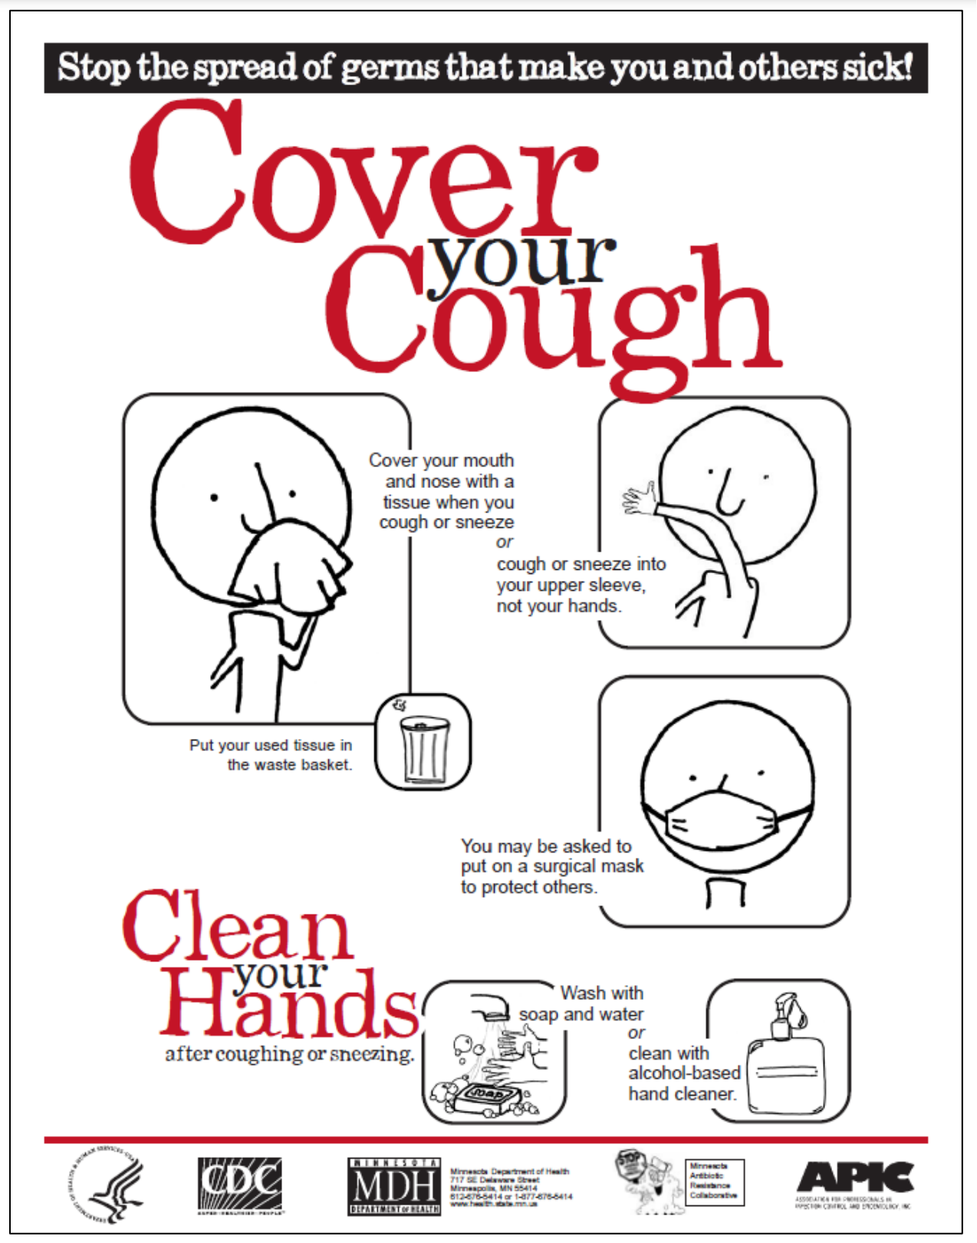

Sharps

Sharps are any material that can puncture or cut human skin or a red trash bag (such
as syringes with needles, needles alone, lancets, razor blades, broken glass, and
similar sharp objects). ALL sharps must be discarded into an approved sharps container.

Sharps Disposal

1. Needles and other sharps are never to be discarded directly into a red bag, red
bag-lined biohazard box or into other waste streams.
2. All needles and sharps must be discarded directly into approved sharps disposal
containers.
3. An approved sharps container shall be available where sharps are utilized.
4. Containers for the disposal of sharps shall be limited to those approved by the
Infection Preventionist.
5. Sharps containers shall not be overfilled. Filled containers shall be properly sealed and disposed of in receptacles lined with a red bag.
6. Sharps disposal containers are puncture resistant, not puncture proof. Filled containers are to be handled with caution; sharps may penetrate under certain conditions.
7. Sharps containers are picked up as needed by a licensed medical waste disposal company.

Guidelines for the Safe Handling of Sharps

1. Sharps are never to be discarded directly into the regular trash.
2. Needles are not to be clipped or bent.
3. The user shall be responsible for proper sharps disposal. Sharps shall not be left on furniture, equipment, or counter tops.
4. Sharps should never be carried in pockets. Needles and other sharps used at a distance from a disposal container shall be transported safely to the disposal area by using a puncture-resistant basin or similar container.

When a Resident Has a Communicable Disease

Additional procedures will be followed when one or more residents are diagnosed with a
communicable disease.

1. Enhanced environmental cleaning and disinfection to maintain a safe and sanitary environment and to prevent, contain, and mitigate the transmission of communicable diseases.
2. Enhanced environmental cleaning and disinfection shall be of all frequently touched surfaces such as doorknobs, handles, and shared items.
3. Enhanced environment cleaning will be performed once per shift and as often as
necessary.
4. All staff and volunteers providing direct care to a resident who has a
communicable disease shall wear appropriate Personal Protective Equipment
(PPE) to prevent exposure to infectious agents through the respiratory system, skin, or mucous membranes of the eyes, nose, or mouth.
PPE may include gloves, gowns, masks, respirators, shoe coverings and eye
protection.
5. The Infection Preventions will consult with the resident’s physician or a local
health department to determine the type of PPE to be used based on the
communicable disease present in the facility.
6. All staff and volunteers will receive additional training regarding the specific
communicable disease and appropriate infection control measures.
7. There shall be separation and care of residents whose illness requires
separation, including quarantine or isolation, from others based on facility policies.

Emergency Infection Control Plan

The plan for facility emergency preparedness developed must address internal and external emergencies and local and widespread emergencies.
When a local state, or federal emergency for a communicable disease is proclaimed or declared, the Infection Preventionist shall develop and implement an Emergency Infection Control Plan that includes infection control measures that are not already addressed in the Infection Control Plan to prevent, contain, and mitigate the associated communicable disease. The COVID-19 pandemic is an example of such an emergency.

The Emergency Infection Control Plan shall include:

1. Infection control measures required by the federal, state, and local government public health authorities for the communicable disease
2. The Emergency Infection Control Plan will be used based on facility infection prevention and control policy and state of emergency requirements.
3. The Emergency Infection Control Plan will be distributed to residents, facility staff, and others as identified by the facility.
4. All staff shall be trained on the Emergency Infection Control Plan.
5. The Emergency Infection Control Plan will be reviewed and updated as necessary, or whenever new infection control measures are recommended by the federal, state, and local government public health authorities, until the proclaimed or declared state of emergency is no longer in effect.
6. Any updates to the plan shall be shared with staff, residents and others as identified by the facility, including each resident's authorized representative.

